VPN - A VPN is a private network that uses a public network to connect two or more remote sites. Instead of using dedicated connections between networks, VPNs use virtual connections routed (tunneled) through public networks. IPsec VPN is a protocol, consists of set of standards used to establish a VPN connection. It provides a means by which remote computers communicate securely across a public WAN such as the Internet.

IPsec - Internet Protocol Security (IPsec) VPN refers to the process of creating and managing VPN connections or services using an IPsec protocol suite. It is a secure means of creating VPN that adds IPsec bundled security features to VPN network packets. IPsec provides Layer 3 security, also suite of protocols that provides confidentiality, integrity and authentication to data. IPsec VPN is also known as VPN over IPsec.

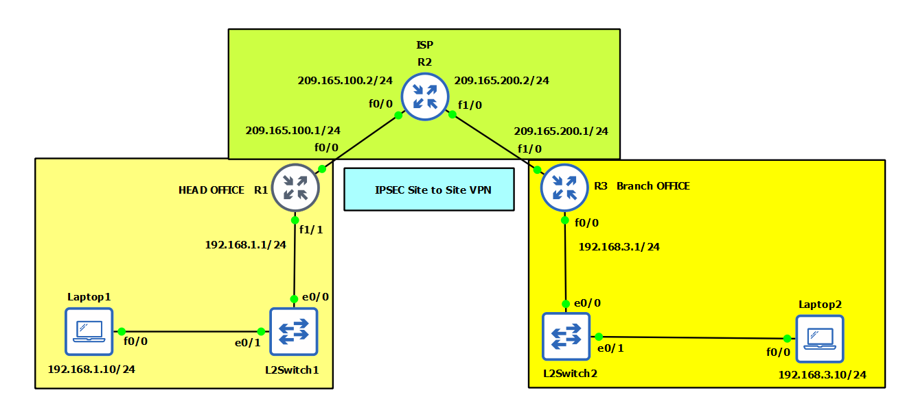Topology

In given Topology, there is One ISP, One Hub as Head Office and One Spoke as Branch Office.

Hub and Spoke have one Laptop each.

Condition

1. All the Routers R1, R2, R3 and Laptops are configured as seen in Topology.
2. All the Devices can communicate with each other Since they are configured in OSPF routing protocol.

For HEAD OFFICE R1

In Phase 1

We create ISAKMP policy and pre-shared key

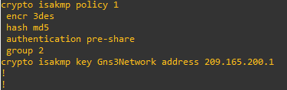

In Phase 2

1) Transform set

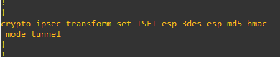

2) Access list

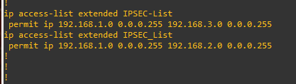

3) Crypto map

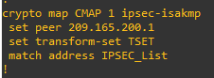

4) Apply to the interface

int FastEthernet 0/0

crypto map CMAP

5) Verify

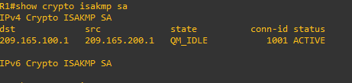

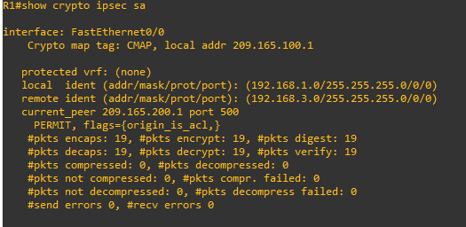

For BRANCH OFFICE R3

In Phase 1

We create ISAKMP policy and pre-shared key

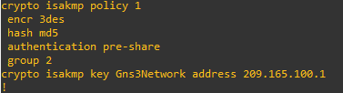

In Phase 2

1. Transform set



1. Access list



1. Crypto map

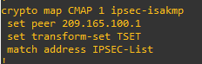

4) Apply to the interface

int FastEthernet 1/0

crypto map CMAP

5) Verify

